PRIME
MEDICAL & DENTAL COLLEGE ISLAMABAD

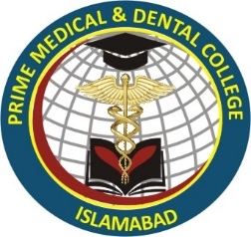

Clinical Rotational Planner 3rd,4th and 5th Year MBBS

